JNCIE-SP MODULAR LAB
SYS-101
Initial System Settings
Task and Solution Guide
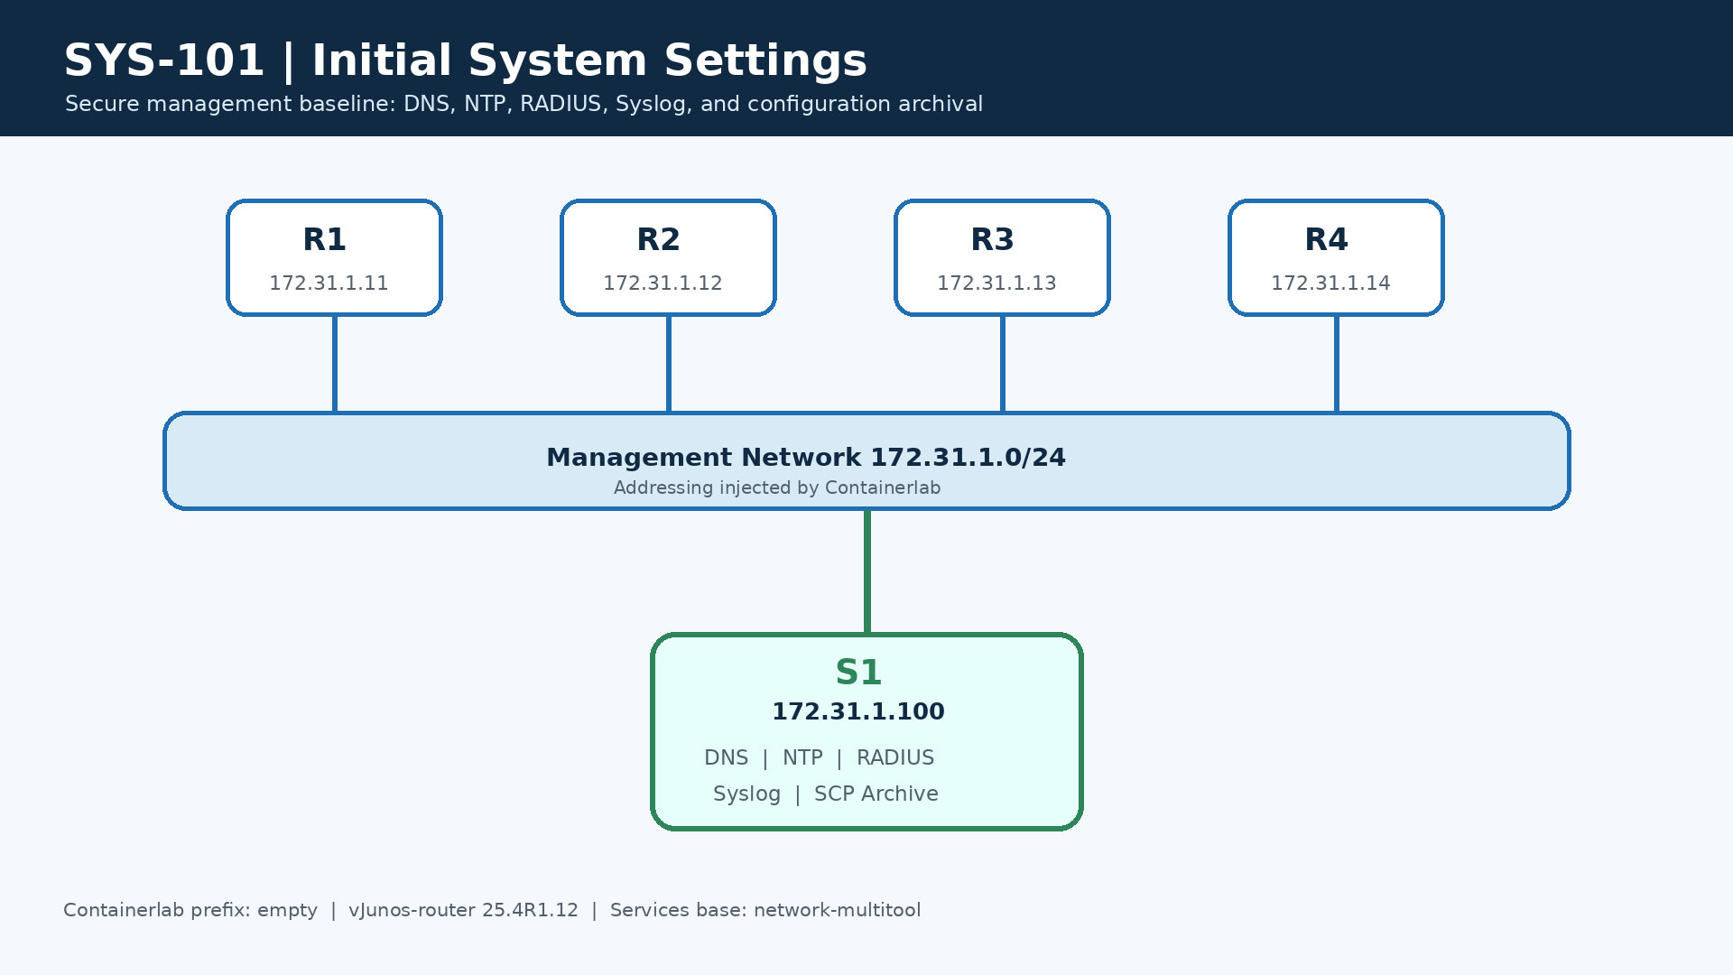
PLATFORM  vJunos-router 25.4 | DURATION  3 hours | TARGET  2 repetitions

Solution Guide — Revision 3
Platform: Containerlab, four vJunos-router 25.4R1.12 nodes, one consolidated services node
Estimated time: 3 hours | Difficulty: Intermediate | Target repetitions: 2

Lab purpose
Build and verify a secure management baseline on R1-R4. Containerlab/vrnetlab
injects management addressing, management-instance, mgmt_junos, and its
default route. Startup files deliberately do not configure those objects.

Addressing
Node | Containerlab management IP | Loopback | Final hostname | Role
R1 | 172.31.1.11/24 | 192.0.2.11/32 | R1 | Junos router
R2 | 172.31.1.12/24 | 192.0.2.12/32 | R2 | Junos router
R3 | 172.31.1.13/24 | 192.0.2.13/32 | R3 | Junos router
R4 | 172.31.1.14/24 | 192.0.2.14/32 | R4 | Junos router
S1 | 172.31.1.100/24 | — | S1 | DNS, NTP, RADIUS, Syslog and SCP archive
Inside each vJunos VM, fxp0.0 is 10.0.0.15/24 and the management next hop
is 10.0.0.2. The 172.31.1.x addresses remain the Containerlab-facing
addresses used from the host and by S1.

Task 1 - Validate baseline and identity
Objective
Confirm startup configuration loading, injected management connectivity, S1
reachability, and production identity.

Requirements
- Deploy all five nodes and verify that they are operational.
- Confirm Containerlab management addresses and the injected fxp0.0 configuration.
- Change bootstrap hostnames to R1, R2, R3, and R4.
- Save deployment and management-interface evidence.

Solution
Deploy and inspect the lab:
make build-services
make deploy
containerlab inspect --topo topology.clab.yml

On every router, replace <NODE> with its node name:
configure
set system host-name <NODE>
commit confirmed 5
run show interfaces terse fxp0
run ping 172.31.1.100 routing-instance mgmt_junos count 3
commit

Do not add management configuration to the startup file. An internal address
such as 10.0.0.15/24 is expected on fxp0.0; the host still reaches the node
through the Containerlab address.

Task 2 - Central and local Syslog
Objective
Create troubleshooting evidence before implementing the remaining tasks.

Requirements
- jncie-sp-messages must record information and interactive commands.
- user-commands must record interactive commands.
- s1 (172.31.1.100) must receive notice messages and configuration changes through mgmt_junos.
- User ops must receive warning messages when that user is logged in.
- Archive three local files with a size of 100 KB each.

Solution
configure
set system syslog archive size 100k
set system syslog archive files 3
set system syslog user ops any warning
set system syslog host 172.31.1.100 any notice
set system syslog host 172.31.1.100 change-log any
set system syslog host 172.31.1.100 routing-instance mgmt_junos
set system syslog file jncie-sp-messages any info
set system syslog file jncie-sp-messages interactive-commands any
set system syslog file user-commands interactive-commands any
commit

The ops target is valid before Task 7 creates the corresponding login template. It becomes useful whenever that identity is logged in.
Verify locally and on S1:
show configuration system syslog | display set
show log jncie-sp-messages | last 20
show log user-commands | last 20
find evidence/services -name '*.log' -size +0c -ls

Task 3 - Management services and retained route
Objective
Enable required management protocols and preserve a remote management route if RPD is unavailable.

Requirements
- Enable SSH, Telnet, and FTP.
- Install static route 10.10.10.0/24 through 10.0.0.2 in mgmt_junos.
- Retain the route if RPD stops.
- Prevent the route from being advertised by dynamic routing protocols.

Solution
configure
set system services ssh
set system services telnet
set system services ftp
set routing-instances mgmt_junos routing-options static route 10.10.10.0/24 next-hop 10.0.0.2
set routing-instances mgmt_junos routing-options static route 10.10.10.0/24 retain
set routing-instances mgmt_junos routing-options static route 10.10.10.0/24 no-readvertise
commit confirmed 5
run show route table mgmt_junos.inet.0 10.10.10.0/24 exact detail
commit
retain preserves forwarding state when RPD is unavailable;
no-readvertise prevents redistribution into dynamic routing protocols.

Task 4 - DNS and time zone
Objective
Provide consistent name resolution and administrative time display.

Requirements
- Use S1 (172.31.1.100) as the DNS server through mgmt_junos.
- Use domain sys101.lab.
- Set Asia/Jakarta as the time zone.
- Resolve and reach s1.sys101.lab through mgmt_junos.

Solution
configure
set system name-server 172.31.1.100 routing-instance mgmt_junos
set system domain-name sys101.lab
set system time-zone Asia/Jakarta
commit
run ping s1.sys101.lab routing-instance mgmt_junos count 3

The expected DNS answer is 172.31.1.100. If an older address is returned, rebuild S1 without cache and redeploy it.

Task 5 - Authenticated NTP
Objective
Synchronize every router with S1 using authenticated NTP.

Requirements
- Configure loopback address shown in the addressing table.
- Use S1 (172.31.1.100) as the operational NTP server through mgmt_junos.
- Use MD5 key ID 1 and key value workbook.
- Trust key ID 1 and associate it with S1.
- Demonstrate an authenticated, reachable NTP association and synchronized status.

Solution
On each router, replace <LOOPBACK> with the address from the table:
configure
set interfaces lo0 unit 0 family inet address <LOOPBACK>
set system ntp authentication-key 1 type md5 value workbook
set system ntp trusted-key 1
set system ntp server 172.31.1.100 key 1 routing-instance mgmt_junos
commit

Use workbook for auth key value. The loopback supplies a usable source identity for this platform combination.
show configuration system ntp | display set | except value
show ntp associations
show ntp status

Wait for nonzero reach and sync_ntp. The association should show SKEY. leap_none instead of leap_alarm, stratum less than 16, reftime not blank. Star * on s1 server.
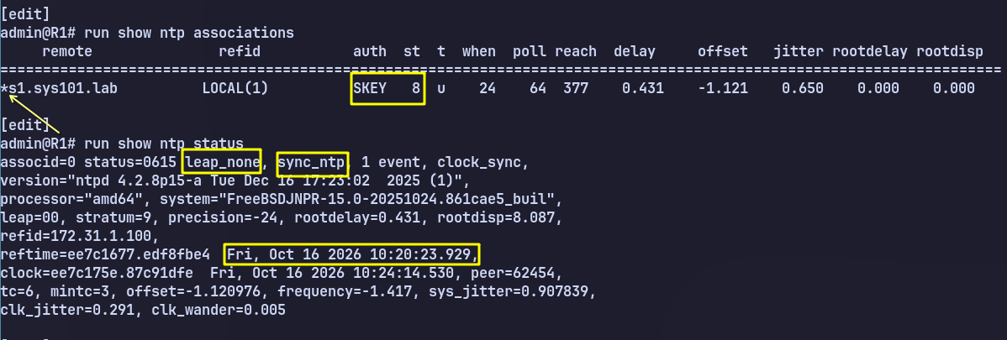

Task 6 - Configuration archival over SCP
Objective
Archive configuration automatically after every commit.

Requirements
- Use S1 (172.31.1.100) SCP with lab / lab123 through mgmt_junos.
- Store files in /tmp on S1.
- Configure transfer on commit.
- Trigger at least one post-configuration archive.
- Demonstrate a non-empty archived configuration on S1.

Solution
configure
set system archival configuration transfer-on-commit
set system archival configuration routing-instance mgmt_junos
set system archival configuration archive-sites "scp://lab@172.31.1.100/srv/ftp/archive" password lab123
commit

Verify:

show configuration system archival
show log jncie-sp-messages | match transfer
show log jncie-sp-messages | match conf.gz
find services/archive -type f -size +0c -ls

The tested vJunos FTP client rejects the internal routing-instance option. SCP is therefore the supported lab method. For manual testing:

file copy /config/juniper.conf.gz scp://lab@172.31.1.100/srv/ftp/archive/R1-test.conf.gz routing-instance mgmt_junos

Task 7 - Authorization classes and RADIUS mappings
Objective
Map RADIUS identities to distinct Junos authorization profiles.

Requirements
- ops-class must have clear, network, reset, trace, and view permissions.
- noc-class must have all permissions but deny clear, configure, edit, and start-shell commands.
- Create local passwordless templates radius-ops and radius-noc for the two classes.
- Create local passwordless template remote with read-only authorization.
- Map RADIUS users ops and noc to their corresponding local templates with Juniper-Local-User-Name.
- Demonstrate permitted and denied actions for each constrained role and read-only authorization for an unmapped RADIUS user.

Solution
configure
set system login class ops-class permissions clear
set system login class ops-class permissions network
set system login class ops-class permissions reset
set system login class ops-class permissions trace
set system login class ops-class permissions view
set system login class noc-class permissions all
set system login class noc-class deny-commands "(clear|configure|edit|start shell)"
set system login user radius-ops class ops-class
set system login user radius-noc class noc-class
set system login user remote class read-only
commit

These are passwordless local authorization templates, not duplicate local credentials. S1 returns these FreeRADIUS attributes:

ops Cleartext-Password := "ops123"
Juniper-Local-User-Name := "radius-ops"
noc Cleartext-Password := "noc123"
Juniper-Local-User-Name := "radius-noc"
readonly Cleartext-Password := "readonly123"

The unmapped readonly identity inherits the special remote template. Test both permitted and denied commands after Task 8 activates RADIUS.

Task 8 - RADIUS authentication with local fallback
Objective
Use centralized authentication first while maintaining local recovery access.

Requirements
- Authentication order must be RADIUS followed by local password.
- Use S1 (173.31.1.100) through mgmt_junos with shared secret workbook.
- Set retry to 1 and timeout to 2 seconds.
- Preserve local break-glass user lab / lab123.
- Prove RADIUS authentication while S1 is available (ops / ops123 ; noc / noc123).
- Prove local fallback while S1 RADIUS is unavailable without causing administrative lockout.

Solution
Keep the current session open:
configure
set system authentication-order radius
set system authentication-order password
set system radius-server 172.31.1.100 secret workbook
set system radius-server 172.31.1.100 routing-instance mgmt_junos
set system radius-server 172.31.1.100 retry 1
set system radius-server 172.31.1.100 timeout 2
commit confirmed 10

Prove login as ops, noc, and readonly from a second terminal. Confirm the commit only after successful tests.

To prove local fallback, temporarily stop RADIUS without removing S1:
docker exec S1 supervisorctl stop radius
ssh lab@R3
docker exec S1 supervisorctl start radius
lab / lab123 must work while RADIUS is stopped. This proves password fallback;
a normal local login while RADIUS is reachable does not prove which method was
used. Verify RADIUS traffic/logs on S1 when needed.

Final verification
bash scripts/verify.sh
Required final line:
RESULT: PASS

Rollback and reset
make destroy
make deploy
enforce-startup-config: true reloads the supplied bootstrap baseline on a
clean deployment; Containerlab injects the management plane again.

